CN Case Study

Tech Startup with 20 employees

Btech Computer Science

Name Roll No.

Vardhaman Munot (B033)

Rishabh Tulshyan (B074)

Vedant Misra (B091)

Riya Adsul (B100)

**Finding and Observations**

Computer networks have a significant impact on the working of an organization.

An efficient network is essential to facilitate the systematic and cost-efficient transfer of information in an organization in the form of messages, files, and resources. The project provides insights into various concepts such as topology design, IP address configuration, and how to send information in the form of packets to the wireless networks of an organization.

The aim of this project is to design the topology of an IT startup company using the software Cisco Packet Tracer with the implementation of wireless networking systems. This company network consists of the following devices:

1) Router (PT)

2) Switches (PT)

3) Server (PT)

6) Wireless Device (Access Point)

7) PCs

8) Laptops

9) Cloud

**● Router**

A router is a device like a switch that routes data packets based on their IP addresses. The router is mainly a Network Layer device. Routers normally connect LANs and WANs

together and have a dynamically updating routing table based on which they make decisions

on routing the data packets. Router divides broadcast domains of hosts connected through it.

● **Switch**

A network switch (also called switching hub, bridging hub, officially MAC bridge is

networking hardware that connects devices on a computer network by using packet switching to receive and forward data to the destination device. A network switch is a multiport network bridge that uses MAC addresses to forward data at the data link layer (layer 2) of the OSI model. Some switches can also forward data at the network layer (layer 3) by additionally incorporating routing functionality. Such switches are commonly known as layer-3 switches or multilayer switches.

**● Network Packet**

A network packet is a formatted unit of data carried by a packet-switched network. A packet

consists of control information and user data, which is also known as the payload.

**● Wireless Network**

A wireless network broadcasts an access signal to the workstations or PCs. This enables

mobility among laptops, tablets, and PCs from room to room while maintaining a firm

network connection continuously. A wireless network also presents additional security requirements.

● **Server**

A server is a computer or system that provides resources, data, services, or programs to other computers, known as clients, over a network. In theory, whenever computers share resources with client machines they are considered servers. There are many types of servers, including web servers, mail servers, and virtual servers.

● **Ethernet**

This is the backbone of our network. It consists of the cabling and is typically able to

Transfer data at a rate of 100mb/s. It is a system for connecting a number of computer

systems to form a local area network, with protocols to control the passing of information and

to avoid simultaneous transmission by two or more systems. Among the different types of

ethernet, we have used Fast Ethernet.

● **Computing Device**

Computing devices are the electronic devices that take user inputs, process the inputs, and

then provide us with the end results. These devices may be Smartphones, PC Desktops,

Laptops, printers, and many more.

**● Internet Protocol**

Internet Protocol (IP) is one of the fundamental protocols that allow the internet to work. IP

addresses are a unique set of numbers on each network and they allow machines to address each other across a network. It is implemented on the internet layer in the IP/TCP model.

**● Simulation Environment**

The simulations of our network topology can be easily achieved using cisco packet tracer.

Using a simulation mode, you can see packets flowing from one node to another and can also click on a packet to see detailed information about the OSI layers of the network. Packet Tracer offers a huge platform to combine realistic simulation and visualize them

simultaneously. Cisco Packet Tracer makes learning and teaching significantly easier by

supporting multi-user collaboration and by providing a realistic simulation environment for

experimenting with projects.

**Topology Used:**

**Star Topology**

Star topology is basically used for Local Area networks in which all nodes are connected to central point called Switch, which connects them into the communication channel.The connections are in such manner that n number of wires are required to connect n number of end devices or nodes.Traffic is generated from central Switch of the star.Central Switch controls communication between all the nodes, message sent by one node reaches Switch first and then it is transmitted to the receiver node.

**Advantages of Star Topology**

* It is very reliable – if one cable or device fails then all the others will still work
* It is high-performing as no data collisions can occur
* Less expensive because each device only needs one I/O port and wishes to be connected with a hub/switch with one link.
* Easier to put in
* Robust in nature
* Easy fault detection because the links are often easily identified.
* No disruptions to the network when connecting or removing devices.
* Each device requires just one port i.e. to attach to the hub.
* If N devices are connected to each other in star, then the amount of cables required to attach them is N. So, it’s easy to line up.

**Disadvantages of Star Topology**

* Requires more cable than a linear bus .
* If the connecting network device (network switch) fails, nodes attached are disabled and can’t participate in network communication.
* More expensive than linear bus topology due to the value of the connecting devices (network switches)
* If middle node(hub/switch) goes down everything goes down
* Middle node requires more resources and regular maintenance because it’s the central system of the star .
* Extra hardware is required (hubs or switches) which adds to cost
* Performance is predicated on the one concentrator.

**Justification:**

Since star topology is easy to set up and add a new node, it also has less components. It is robust and reliable and costs less than mesh topology. The data transfer rate is also high. It is fault tolerant as even if one node fails the rest of the network won't be affected.

**Assumptions**:

1. It is an IT start-up having only 20 employees, so we have assumed it to be situated at only one location
2. We have used star topology as it is a reliable and robust topology but is not as costly as mesh
3. We have considered the office space to have 3 rooms, namely the main office, conference room and the server room (server is considered as it is an IT company)
4. The main office will have 18 pcs for the employees
5. The conference room has an access point to which wireless devices like laptops and printers can be connected
6. The server room has the main server and a pc

**Implementation:**

* **The Entire Network**

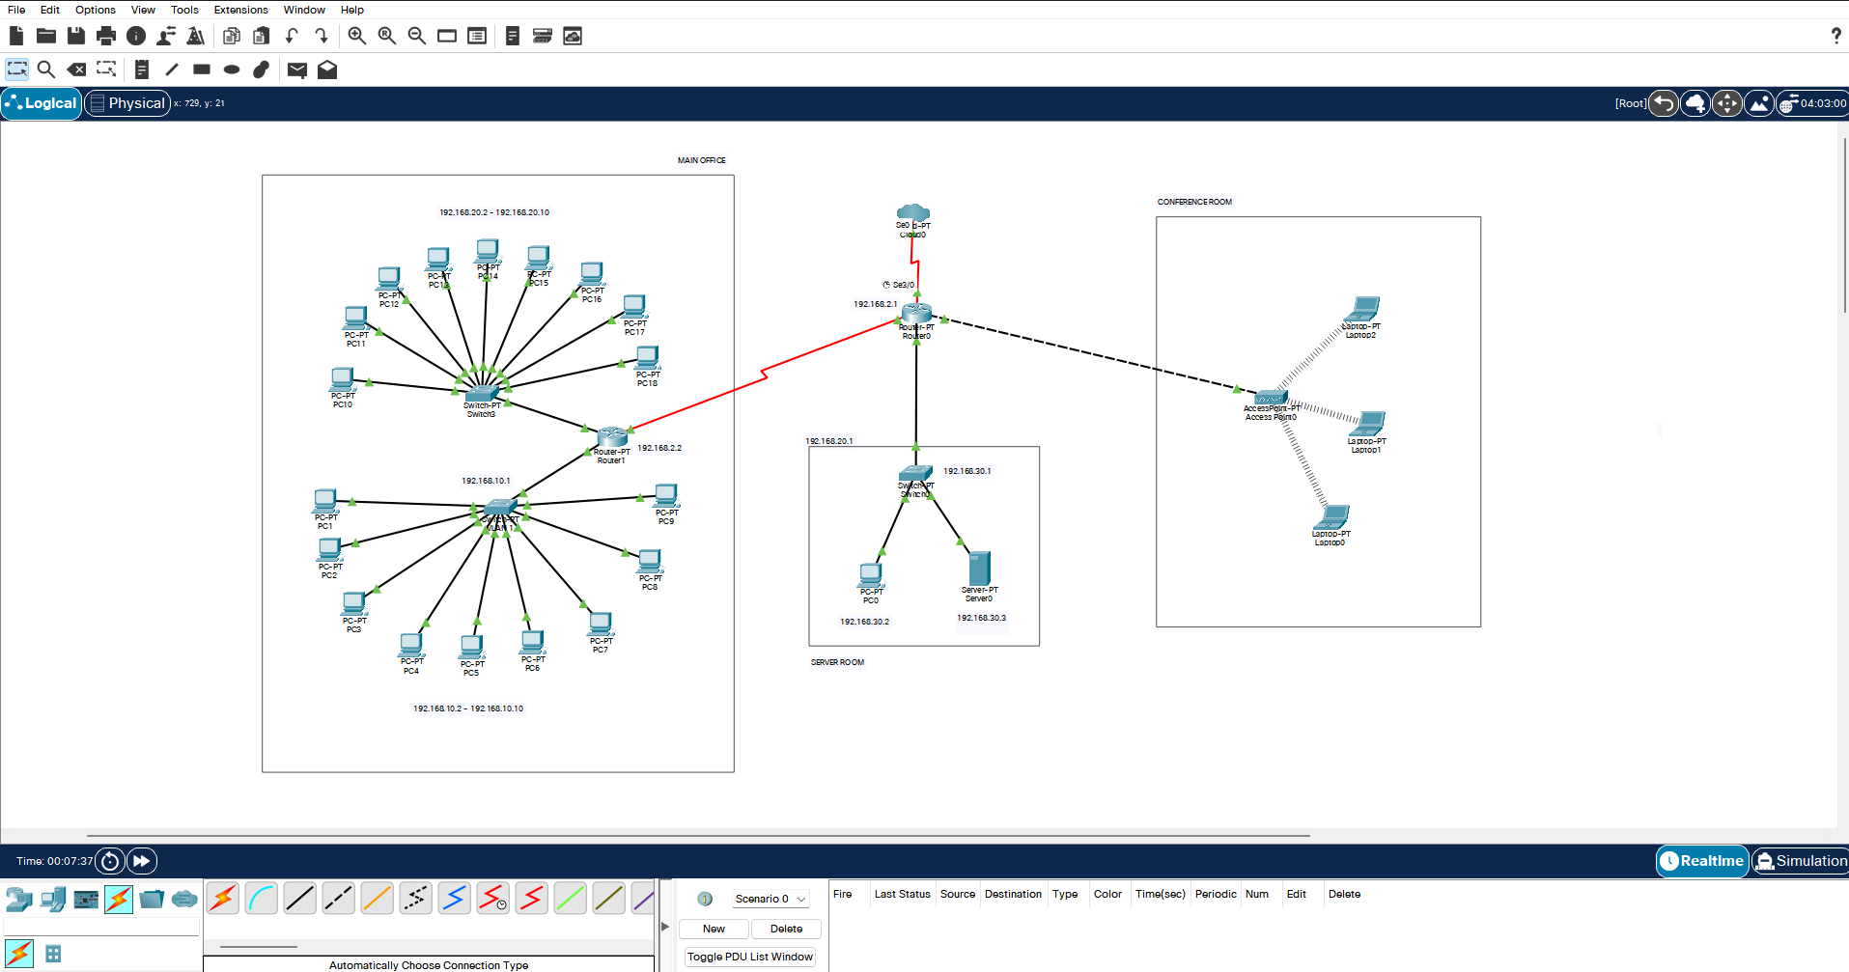

* **MAIN OFFICE ROOM**

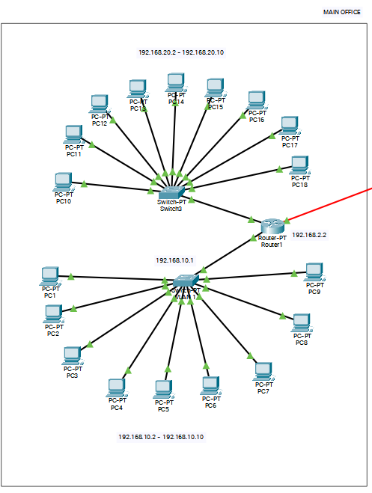

* **SERVER ROOM**

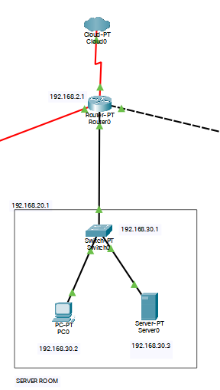

* **CONFERENCE ROOM**

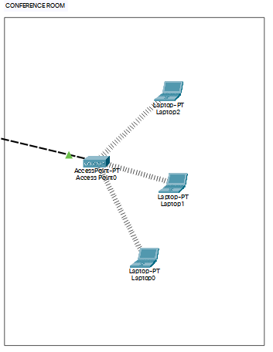

* **SIMULATION TABLE**







